**Excel Assignment – 6**

**1. What are the various elements of the Excel interface? Describe how  
they're used.**

Excel has two main UI components: The Interface Components and the Workbook Components.

***Interface Components***

The interface components of Excel include the Quick Access Toolbar, Ribbon, Name Box, Formula Quick Menu, Formula Bar, Status Bar, Worksheet View Options, Zoom Slider Control, and the Zoom Percentage Indicator.

***Quick Access Toolbar***

The Quick Access Toolbar is found on the top-left of the Excel window which contains the commonly-used commands in Excel.  By default, this contains the save, undo, and redo commands.

***Ribbon***

The Ribbon interface contains the commands that are available for use in Excel. This has multiple tabs including the File, Home, Insert, Page Layout, Formulas, Data, Review, View, Developer(added manually), and Help tabs.

The tabs are then subdivided in groups based on the usage of the commands. For example, in the Home tab, the commands are grouped in Clipboard, Font, Alignment, Number, Styles, Cells, and Editing.

***Name Box***

The Name Box is an input box which normally displays the name or location of the active cell on the worksheet.

***Formula Quick Menu***

The Formula Quick Menu beside the Name box is a shortcut when you want to insert a function. If you click the *fx*option, the Insert Function will pop-up to let you choose which Excel function would you like to use.

***Formula Bar***

The Formula Bar is found just beside the Formula Quick Menu. This allows you to enter or edit data, formula or a function that will appear in the selected cell whose name or location appears in the Name Box.

***Status Bar***

The Status Bar in the bottom-left corner of the Excel window displays various information about the current mode of the workbook.

***Worksheet View Options***

The Worksheet View Options lets you choose which of the 3 worksheet views you want (Normal, Page Layout, or Page Break Preview). By default, the worksheet view is set to Normal.

***Zoom Slider Control***

The Zoom Slider Control helps you zoom in and zoom out the worksheet.

***Zoom Percentage Indicator***

The Zoom Percentage Indicator displays the zoom percentage just beside the Zoom Slider Control. By default, it is set to 100%.

**2. Write down the various applications of Excel in the industry.**

Some of the major **uses of Microsoft Excel** and how different people or organizations are using it for their needs. They are as follows:

* Data Entry and Storage
* Performing Calculations
* Data Analysis and Interpretation
* Reporting and Visualizations
* Accounting and Budgeting
* Collection and Verification of Business Data
* Calendars and Schedules
* Administrative and Managerial Duties
* Forecasting
* Automating Repetitive Tasks

**3. On the ribbon, make a new tab. Add some diﬀerent groups, insert  
commands in the groups and name them according to their commands  
added. Copy and paste the screenshot of the steps you followed.**

How to customize ribbon in Excel

Do on of the following:

* *File > More… > Options > In Excel Options window click on* ***Customize Ribbon***
* Right-click on the ribbon and select Customize the Ribbon… from the context menu:

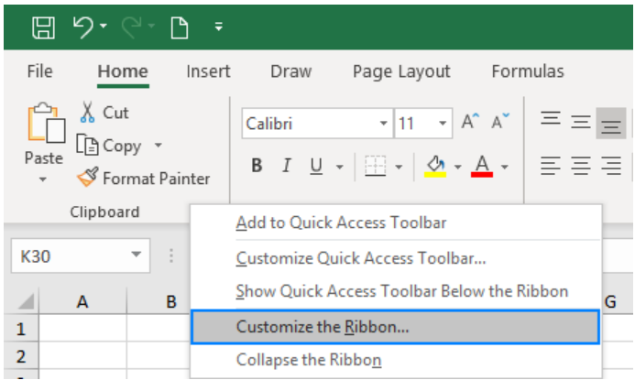

Create a custom ribbon tab

1. In the Customize the Ribbon window, under the list of tabs, click the **New Tab** button.

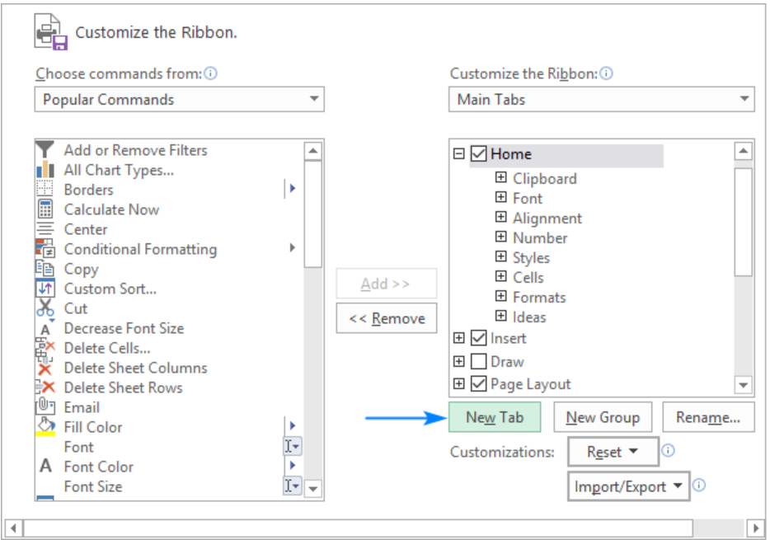

This adds a custom tab with a custom group because commands can only be added to custom groups.

1. Select the newly created tab, named New Tab (Custom), and click the Rename… button to give your tab an appropriate name. In the same manner, change the default name given by Excel to a custom group.
2. When done, click OK to save the changes.

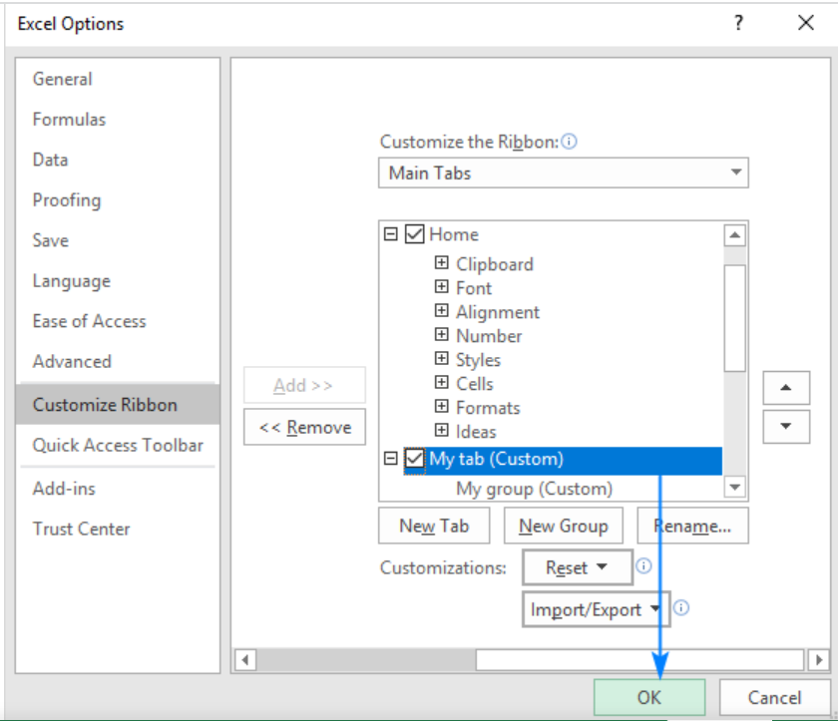

As shown in the screenshot below, our custom tab is added to the Excel ribbon immediately, though the custom group is not displayed because it is empty. For the group to show up, it must contain **at least one command**.

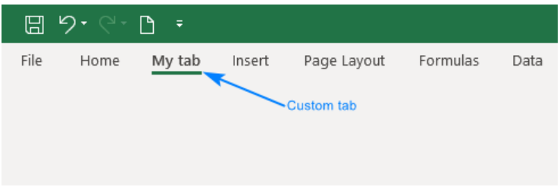

**How to add a custom group to a ribbon tab**

To add a new group to either a default or custom tab, this is what you need to do:

1. In the right part of the Customize the Ribbon window, select the tab to which you'd like to add a new group.
2. Click the New Group button. This adds a custom group, named New Group (Custom), at the bottom of the list of groups, meaning the group displays on the far-right end of the tab. To create a new group in a specific location, select the group after which the new group is to appear.

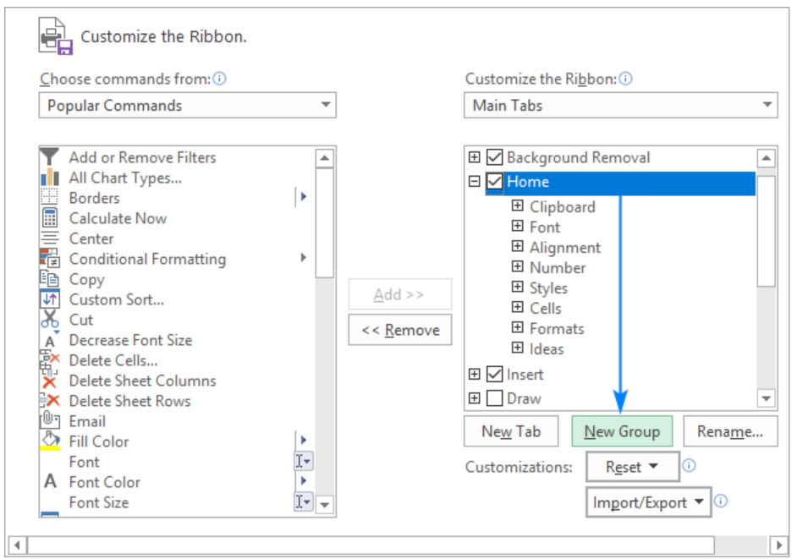

1. To rename your custom group, select it, click the Rename… button, type the desired name, and click OK.
2. Click OK to save and view your changes.

**How to add a command button to Excel ribbon**

Commands can only be added to **custom groups**. So, before adding a command, be sure to create a custom group on an inbuilt or custom tab first, and then perform the below steps.

1. In the list under *Customize the Ribbon*, select the target custom group.
2. In the *Choose commands from* drop-down list on the left, select the list from which you want to add commands, for example, *Popular Commands* or *Commands Not in the Ribbon*.
3. In the list of commands on the left, click the command you want to add.
4. Click the **Add** button.
5. Click *OK* to save the changes.

As an example, we are adding add the Subscript and Superscript buttons to the custom tab that we created:

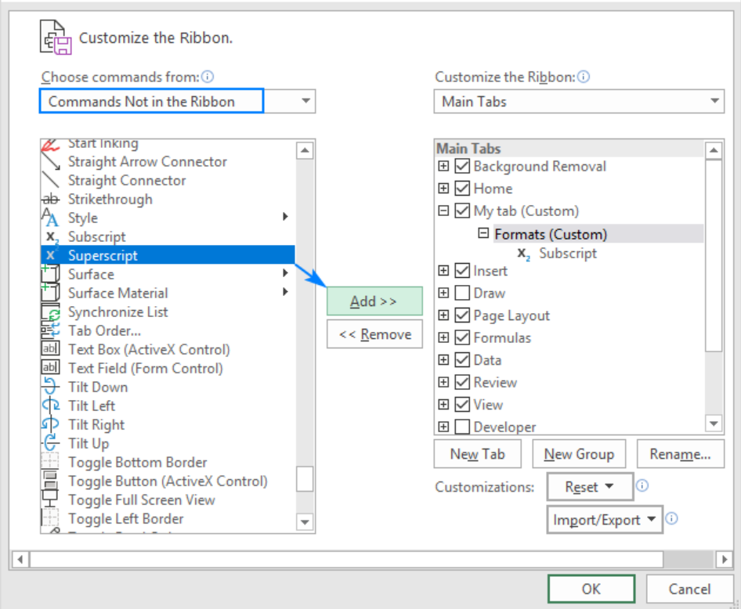

As the result, we now have a custom ribbon tab with two buttons:

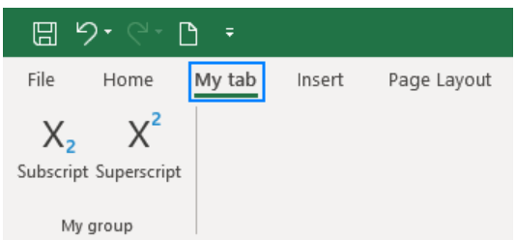

**4. Make a list of diﬀerent shortcut keys that are only connected to  
formatting with their functions.**

Here are 15 keyboard shortcuts to quickly format your data and cells as well.

1. **Ctrl + Shift + ~**  Apply general format.
2. **Ctrl + Shift + $**  Apply currency format.
3. **Ctrl + Shift + %**  Apply percent format.
4. **Ctrl + Shift + ^**  Apply scientific format.
5. **Ctrl + Shift + #**  Apply date format.
6. **Ctrl + Shift + @**  Apply time format.
7. **Ctrl + Shift + !** Apply number format.
8. **Ctrl + 1**  Open the Format Cells dialog box.
9. **Ctrl + B**  Apply or remove bold format.
10. **Ctrl +** **I**  Apply or remove italic format.
11. **Ctrl + U**  Apply or remove underline format.
12. **Ctrl + 5**  Apply or remove strike format.
13. **ALT + H + B + A** Applies borders to the cells
14. **ALT + H + B + T** Gives an outline border to the dataset
15. **ALT + H + O + W** [Autofits](https://trumpexcel.com/autofit-excel/) column widths

**5. What distinguishes Excel from other analytical tools?**

Excel is great for general purpose data analysis. What makes it stand-out compare to other analytical tool is because of below reasons.

1. It’s easier to learn excel.
2. Most business users would have access to it.
3. Most of them know how to use it.

**6. Create a table and add a custom header and footer to your table**

Add a Header or Footer

1. Click the **Insert** tab.
2. Click the **Text** button.
3. Select **Header & Footer**.



1. Click in the header section where you want to add text.
2. Enter custom text or select a pre-defined header from the Header & Footer Elements group or Header menu.
3. To view the footer, click the **Go to Footer** button.



1. Click in the footer section where you want to add text.
2. Enter custom text or select a pre-defined footer from the Header & Footer Elements group or Footer menu.

